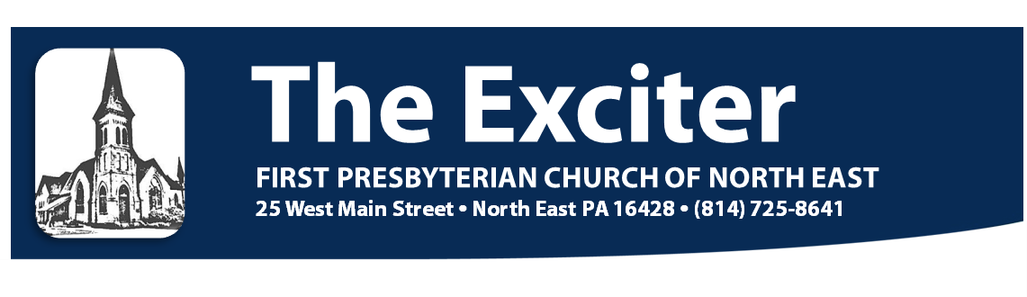
No. 560 September 2016


CHRISTIAN EDUCATION NEWS

Rally A”Round” for Pizza,
Fun, Faith, Fellowship And Sunday School Classes on September 11.

It’s that time of year again - new beginnings, fresh starts and another exciting year of opportunities with your church family. On Sunday, September 11 a new Sunday school year will begin at the First Presbyterian Church of North East. Classes will begin at 9:45 A.M. for children and adults alike.

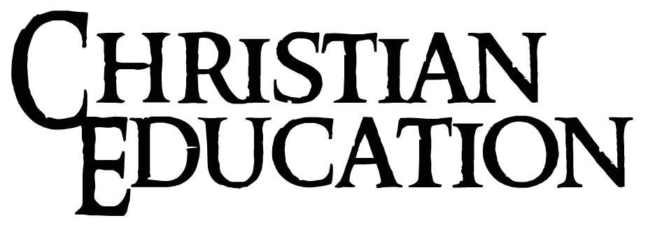
Following the start of a new Sunday School year; plan on joining with your family and friends to, not only kick off the new Sunday School year, but to enjoy extended friendship and fellowship at Rally Day. This year’s Rally Day will include various types of pizza, including desert pizzas, as well as salads and treats. Please rally a”round” with the Christian Education Committee and join your FPCNE family and friends for lunch, fellowship and play. You won’t have to travel anywhere this year, other than around the tables to choose your pizza, as we will celebrate the kick off of Sunday School in our Fellowship Hall, immediately following the 11:00 A.M. church service

This year’s Rally Day will definitely be one to remember and a great kick-off for this year’s Sunday School theme of “God is With You Wherever I Go” (Joshua 1:9).

We have exciting new Sunday School curriculum for Kids, Youth, and Adults this year. You are invited to join a FPCNE Sunday School or Bible Study class to help you follow and grow in your own spiritual journey in 2016-17.


FALL 2016 SUNDAY SCHOOL OPPORTUNITIES

SUNDAY SCHOOL CLASSES BEGIN ON SUNDAY, SEPTEMBER 11 AT 9:45 A.M.

GODLY PLAY: AGE 4 & KINDERGARTEN
Godly Play is a method of Christian education and spiritual direction for preschool and Kindergarten-aged children. The goal of Godly Play is to teach children to become more fully aware of the mystery of God's presence in their lives. This Montessori approach to education will help your child learn the building blocks of faith through reenacting Bible stories and other play techniques while being open to others, to new ideas, and to the future in creative ways.

CHRISTIAN EDUCATION NEWS, CONTINUED:

GRADES 1 AND 2
Grade 1 & 2 curriculum focuses on learning to read while exploring Bible stories and verses that children are able to understand and recall. Children learn that God wants our trust and obedience, which leads them to Jesus, their Savior. Gospel Light confidently guides the teaching of the Bible—pure and simple, in contemporary and creative ways that will lay God’s Word as the foundation for your kids’ lives.

GRADES 3, 4, AND 5
Gospel Light’s “Give Me Jesus” for Upper Elementary students continues with the format of the 1st and 2nd grade curriculum. The curriculum is designed to use Bible stories and verses that the children understand and in addition, help them to develop meaningful relationships and an understanding of Jesus as our Savior. Students also discover what the Bible says about popularity, success, failure, friendship, rules and more. Kids develop Bible study skills, grow in Christian maturity and respond by serving Jesus in church and the community.

FAITH AND FELLOWSHIP CLASS: YOUTH GRADES 6 THROUGH 12
Sundays at 9:45 am in the Youth Room, taught by in a rotation by Steve Seymour, Tom McClure, and Katie Gallagher; along with Guest Teachers to be determined.

Our new Youth Sunday School class will focus on specific Bible Study along with discovery of what it is like to “Be the Church.” Our youth will discover the love of Jesus Christ and realize how God has uniquely created each of them with certain passions, talents, and interests to impact the world for Christ. In addition, many Fellowship opportunities and activities will be interwoven throughout the course of the year both in and outside of class setting.

ADULT SUNDAY SCHOOL 2016-2017

SAINTS:
(FOR ANY AND ALL ADULT LEARNERS)
This class is designed for those who are life-long learners in God’s word. Join the Saints group as they continue to study the word of God using the Bible; as well as additional resources.

SEEKERS: “OPEN YOUR BIBLE” STUDY
(FOR 20 – 40 SOMETHINGS)
The Seekers began last year and has been successfully self-directed by attendees. It is a unique class, which will help participants explore and know God’s love and grace. The focus and format of this class is different from any others offered. This class will begin the year with an “Open Your Bible” study session with details to follow as plans are finalized.

FINANCIAL PEACE UNIVERSITY IS COMING SOON.
Our Church's Christian Education committee is excited to offer Dave Ramsey's Financial Peace University class this fall! Many folks in our church and community have found the class to be well worth the time and effort, and in many cases life-changing! The class will be held in 9 sessions, starting on Sunday, Sept. 11 @ 6:00 P.M., going through November 6. Topics include retirement savings, major purchase decisions, and family financial communication. Materials can be ordered online (http://www.daveramsey.com/store/financial-peace-university/financial-peace-university/cFpuClasses.html), for approximately $100.00. Alternatively, if we order in bulk through the church, there is a savings of $10.00. You can register on a sign-up sheet in the Church Office. Jenn Lucore McClure will facilitate the class, and can answer any questions you have (Lucore@hotmail.com). Pray on this. It is a wonderful experience!

KIRK KIDS AND PRAYER & PRAISE

Kids Sunday School Prayer & Praise
All children will gather in our Prayer & Praise room with CE Director, Donna Banks, after Sunday School for 15 minutes of collective songs, prayer, weekly offering, announcements, and other fun. Parents can pick up your children in the Prayer & Praise room on the second floor of the C.E. building at 10:45 A.M. or at Ruth’s Corner in the Assembly Room.

CHRISTIAN EDUCATION NEWS, CONTINUED:
Kirk Kids – age 4 – 5th graders
“…when kids worship God, amazing things happen!”
Sundays at 11:00 A.M., taught by Kirk Kids Team volunteers
Kirk Kids is a creative, innovative worship experience that touches the heart of God - and changes the hearts of children. From the moment kids arrive at Kirk Kids they'll focus on God just like their parents in the sanctuary. Our prayer is that your children will respond to God with open hearts and willing hands as they praise God with fun and meaningful songs while celebrating God's loving attributes and mighty works.

Kirk Kids takes place during the 11:00 A.M. Sunday worship service. Parents should bring their children to the sanctuary service first where kids will be invited to have a special time of prayer with Pastor Townsend before being excused to go to Kirk Kids. The children will be returned to the Assembly Room at the end of worship so parents can meet them at “Ruth’s Corner” around the Noah’s Ark children’s table.

In any month of Sundays, Kirk Kids will feature:
- one Sunday of a seasonal craft project
- two Sundays of the month will resemble a mini-version of our Adult Service
- one Sunday of popular animated DVD faith lesson series including various faith and fun game activities

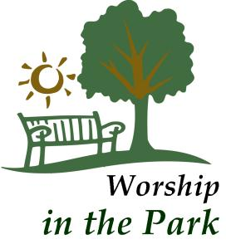
OUR ANNUAL OUTDOOR WORSHIP SERVICE WILL BE HELD ON SUNDAY, SEPTEMBER 4 IN GIBSON PARK AT 9:30 A.M. This will be our final combined worship service for the summer. We will return to our normal worship schedules at 8:30 and 11:00 A.M. and also resume Sunday School classes on September 11. Please bring a lawn chair or blanket for sitting. In the event of rain, we will hold the service indoors at FPCNE.


WE’RE BACK TO OUR NORMAL WORSHIP SCHEDULE ON September 11! The weekly 8:30 A.M. CONTEMPORARY WORSHIP SERVICE gets back on schedule, so you can get up bright and early to PRAISE THE LORD! The LATE WORSHIP SERVICE also returns to 11:00 A.M. on September 11. We’re looking forward to a wonderful fall at FPCNE!


Mark your calendars for September 18. You don't want to miss Bible Sunday. During the 11:00 A.M. service, children in Godly Play, Second Grade, and Sixth Grade will receive a new Bible from the Christian Education Committee.

A SPECIAL COFFEE HOUR!


The Worship and Music Committee would like you to join with us in celebrating the marriage of Pastor Gregg Townsend and Jane Livingston who were wed in August. The coffee hour following the service on Sunday September 25, 2016 will be in their honor. Please join us with well wishes for the couple as we celebrate the union of our two friends.

POSITION AVAILABLE

We are in need of a new Bell Choir Director. If you are interested, please contact the church office (725-8641) or see Pastor Gregg.

2015 MISSION TRIP EXPERIENCE

I have begun writing this article numerous times and have written and rewritten. I finally realized that I have done this because I so much wanted our readers to experience the same love of Jesus that I myself, and other members of our team experienced this summer in Philippi, West Virginia. It is difficult to convey because our Mission Experience was such a passionate undertaking and experience. So if you can bear with me, I am going to write in the first person, from my “heart.”

To begin, this is the story of a journey of a Mission Team of various ages and experiences who traveled to Philippi, West Virginia this summer – and MADE A DIFFERENCE. Our team included John Luchs, Krissy Cole-Lane, Terry Andrews, Garrett Connors, Makayla Albney, Krista Banks, Cole Elkin, Patti and Joe Kuna, Evelyn and Vivian Daugherty and myself, as their leader.

I know that many of our team members began this trip a little apprehensive, not really knowing what to expect, and definitely being asked by the Lord, to “step out of their comfort zones.” Nevertheless, we were eager and willing to attack, with our team’s “laundry list” in hand, of jobs to check-off and complete for our host family, the Crostons, which included Gregg and Bryan and their three children Khia, Jaylynn, and Travis.

After a long day of travel on our first Sunday, we checked in and participated in all of the “mandatory” meeting –stuff before embarking back to our dorms to get ready to begin our adventure. The team was phenomenal throughout the week, from the start of the day on Monday to the end of the week on Friday. We laughed, cried, sighed, were “stretched” to the max physically, but with “strong” spirits worked very, very, very hard. I found myself being more inspired as each day passed by the numerous amazing gifts the Lord bestowed upon us. I kept thinking of the parable of the fishes and the loaves, because in manpower, strength and will-power, that is what he provided us, as we tackled and completed each and every job (AND MORE) in order to make the Croston home a safer and more comfortable place to live.

Some of these physical jobs included the replacement of two doors and windows within the home. {According to Gregg, this will be the first time in three years that they will be able to lock their door when they leave home (as the previous door did not lock). In addition, our team not only removed wallpaper, but repaired several holes and deteriorating plaster, as well as painted the kitchen, living room and two bedrooms for the family.

Though we were provided with the strength to continue and complete the “laundry list” of jobs; that truly was not the focal point of the gifts that were bestowed upon us during our week in Philippi. I personally was able to experience first-hand (as were all of our team members) the love provided through Jesus Christ as we not only developed meaningful friendships with Gregg, Bryan and the children; but some of our members were even able to “witness” to both Gregg and Bryan. In addition, our team members were also able to connect with many members from other teams, developing friendships and bonds with others who also joined the Mission Experience in Philippi that week; and most especially developed strong bonds among our own team. HIS message was conveyed and delivered to us through the selfless acts from friends and families; the stories of other Mission teams and families and through the laughter, tears and connections that developed among our team members. Our 2016 Mission Experience was one of the most unforgettable, impactful experiences I have ever participated in. It truly was memorable and I was so truly blessed by a loving, giving, and perseverant team. Thank-you John, Krissy, Terry, Garrett, Makayla, Krista, Cole, Evelyn, Vivian, Patti, and Joe for helping me see the love and light of our Lord Jesus Christ during a most impactful week!
God Bless,
Donna Banks

“LIKE” US ON FACEBOOK, AND KEEP UP ON THE LIFE OF THE CHURCH. We post important news and church happenings and upload lots of great photos and videos. Have something you’d like to share? Send it to Patti in the Church Office at office@fpcne.org, and we’ll post it for you.
MISSIONS NEWS

Thank you to everyone who participated in the Adopt-a-Student program. On September 18, 2016 we will be having a Committee Day on this day. Your Mission Committee along with other committees will have tables set up in the assembly room to outline and talk about the programs each committee is involved in and what date they will happen. It is your Session’s hope that, if the members are informed of the events, more people will participate in the events.
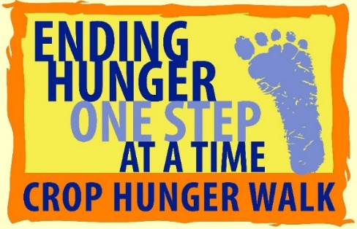
Crop Walk
September 25, 2016
Presque Isle State Park / Beach 1 Parking Lot
12:30 tailgate party
Registration @ 1:30 P.M. / Walk @ 2:00 P.M.

CROP Hunger Walk funds assist all over the world in ending hunger through programs on food provision and development, clean water, vulnerable children, refugee programs and emergencies. The money we raise helps provide for immediate needs and helps makes sustainable changes for the long haul. For more information on who benefits, see our events page.

Church World Service is working with partners in the U.S. and around the world to build interfaith and intercultural coalitions to eradicate hunger and poverty and promote peace.

The complete walk has been changed to 5 1/2 miles along Presque Isle State Park and is no longer at Stone Jetty but Waterworks near the Rotary Pavilion.

A shorter 1-mile walk is available which goes to the Stull Center and returns on the Bay side.

The Erie walk is the largest Crop Walk in Pennsylvania! Of the money raised, 25% will be given to the local food pantries to help the hungry here in Erie.

Frequently Asked Questions
Will there be a water stop?
Yes, there will be a water stop along the course at Water Works
What is the course?
The Walk is a 5.5-mile circle: up the Lake Side to Waterworks.
What if I have trouble?
There will be Emergency help available for any trouble or assistance.
How does this walk help Erie?
25% of all funds are given as grants to local hunger fighting agencies
Additional information or questions can be directed to the CROP walk office at Lamb of God Lutheran Church in Erie: 825-8830
Extensive information about the CROP walk and its important mission can be found on the Church World Service website listed on the right column. Please visit the main site and sign up to receive the latest updates and news about the program.
Find out more about our Erie Walk at: www.crophungerwalk.org/eriepa
This year we are installing some changes here at church. They are as follows:
- Each person or family is responsible for their packet
- No blanket donations, please. Make sure each person or family you sponsor receives money.

THANK YOU CHERRY PIE VOLUNTEERS!

I want to personally thank everyone who came to help in any way for this year’s cherry pie making. We made 1046 pies in 4 days. That is a new record of both pies and days, but it wasn’t without help from some wonderful people. So, thank you to everyone who helped.
God bless,
Ashley Connors

IF YOU HAVE A PRAYER REQUEST, speak with Pastor Gregg, call Patti in the church office (814-725-8641), or email our prayer chain (jlivingston@neo.rr.com or office@fpcne.org). Email us if you’d like to be added to our email prayer chain.
PRESBYTERIAN WOMEN NEWS

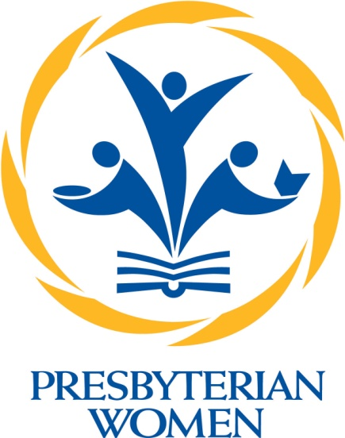
On behalf of the Presbyterian Women of our “faith community,” we thank all those husbands, wives, sons and daughters, grandchildren, cousins, neighbors and friends who helped to make our Cherry Pie Baking for Mission this year a great success. Thanks to Ashley Connors, who did a superb job organizing and encouraging all of us! The dollars earned will all go to mission projects both here and in our greater country and in the world. The monies will be given to feed, clothe, and enable God’s children to know of His love for them. Again we thank you!

We, the Presbyterian Women, also plan a full year of study and service this coming year. The PW book club with Marge Campbell as leader will begin on Thursday, September 8 at 2:00 PM in the conference room at the church. The first book will be The Secret Chord by Geraldine Brooks, if you wanted to get a copy before the first meeting. If you have any questions, please contact Marge Campbell at 725-1183. On Wednesday, September 14 at 2:00 PM the “Knitting and Crocheting for Peace circle” (beginners welcome!) will have their first gathering. We will share patterns and ideas and prepare for a special time together. Then on Tuesday, September 20 at 2:00 PM the first quilting circle with Pauline Fisher will begin. We are very excited to resume this fun experience as we did during our preparation for our bicentennial celebration. Beginners are also welcome to this organizational meeting. These circles including the Square Circle will offer devotions, study and fellowship for all our women. Please plan to join at least one group and perhaps learn a new skill, serving others along the way. See you at a circle!

Presbyterian Women of Lake Erie Presbytery
Fall Gathering – Saturday October 15 - 9:30-1:30 at
Wayside Presbyterian Church
“Mission Matters”
“I can do all things through him who strengthens me.” Philippians 4:13

Keynote speaker- 2015-2016 Northern Ireland YAV (Young Adult Volunteer) -Emma Haas
Emma will share her experience volunteering with the Presbyterian Church as a YAV. You will learn about Northern Ireland and some of its tragic history of communal violence and how the YAV’s work with local churches and community projects to address the legacy of division and help lay foundations for a positive, shared future, particularly through work with youth and children.
Emma will also share details about the YAV program. This exciting mission program is positively impacting the lives of our youth and showing us that Mission Matters!
There is more! We will have breakout sessions on:
- Crafting – Make a card for yourself and one to send to a YAV.
- Hands on Mission – Work with Emma to get supplies ready for a YAV program in New
Orleans.
- Bible Study – Introduction and discussion on the PW Bible Study “Who is Jesus”
- Mission Matters- Learn about Mission Opportunities using the Presbyterian Mission Catalog.
- And more!
Enjoy the fellowship of PW from all over our Presbytery!
Save the date! Saturday October 15th- More information to follow
Hope to see YOU there!

LIBRARY SPOTLIGHT: FALL INTO READING

Welcome to the Library. Relax in your favorite chair with a good book.
CHURCH LIBRARY

Our library has a variety of great books for your reading pleasure: Old and New Testaments, The Holy Spirit, fiction, history, crafts, large print, children, etc. The library ladies will be glad to assist you in finding a good book.
The Library Board

A NOTE ABOUT COFFEE HOUR

It is that time of year again where we have two coffee hours, that means two sets of snacks to go with coffee hour. We need your donations of cookies or any other snack to offer at coffee hour. You may place them in the kitchenette. Also, you can sign up to do a coffee hour on the bulletin board right outside the office. Thank you.


MUSIC MINISTRY NEWS

There are many opportunities to get involved in FPCNE Music Ministry.

JOIN OUR CHANCEL CHOIR
Joining the Chancel Choir is a fun and rewarding way to serve the church. Weekly rehearsals will resume on Thursday evenings at 7:30 P.M. beginning September 8. We welcome our youth from grade 7 and up to sing with us. The Chancel Choir sings at the 11:00 A.M. worship service, typically three times per month.

See our Director of Music Ministry, Jane Livingston for any questions, or just show up on Thursday evenings at 7:30 p.m.

JOIN THE WORSHIP TEAM
Do you like to sing contemporary Christian music? Do you play guitar or other instruments? We'd like to add a few more numbers to our Worship Team. The Worship Team practices on Sunday mornings at 7:45 A.M. and plays each week for the 8:30 A.M. worship service. Speak with Jane Livingston.

STAY TUNED FOR INFORMATION ON OUR BELL CHOIR AS WE CONTINUE TO RECRUIT FOR A NEW BELL CHOIR DIRECTOR



SERVICE SCHEDULE

DATE |  | USHERS
September 4 |  | Dave Meehl, John Wilcox, Roger Meehl, Dianne Tyler, Evelyn Daughrity
September 11 |  | Bob & Sandy Nelson, Ron Blosser, Al Mohnkern, Vivian Daughrity
September 18 |  | Vern Hurlburt, Joe & Sue Spacht, Garrett Connors
September 25 |  | Kathy & Lynn Peterson, Barb Blount, Steve Seymour, Cole Elkin
October 2 |  | Dave Meehl, John Wilcox, Roger Meehl, Dianne Tyler, Evelyn Daughrity
October 9 |  | Bob & Sandy Nelson, Ron Blosser, Al Mohnkern, Vivian Daughrity
October 16 |  | Vern Hurlburt, Joe & Sue Spacht, Garrett Connors
October 23 |  | Kathy & Lynn Peterson, Barb Blount, Steve Seymour, Cole Elkin
 | October 30 | Jerry Weinheimer, Bob Murray, Tom Schenker, Peggy Walsh

Always, we begin again.

