AN ANGEL APPEARED TO THEM

MESSENGERS OF GRACE: LIFE in An Angel-filled World

2017 Advent Program
First Presbyterian Church of North East, PA
December 3, 2017, 4:00 P.M.
Gregg D. Townsend, Pastor

LIGHTING OF THE ADVENT CANDLES

* HYMN Savior of the World

Come Emmanuel; Savior of the world we wait for you
Holy Son of God; Light of our salvation love so true
The child sent from heaven to earth will bring us life anew
Emmanuel, Savior of the World we wait for you

You are the hope, a candle shining bright; You are near Emmanuel
God with us You, are the Promised One; You we worship and adore
All praise to you, the everlasting Father
The Prince of Peace, You will reign forever (Chorus)

WELCOME Donna Banks

* HYMN Have You Heard? See insert

“An Angel Appeared to Them”

SCENE 1: The Family

SPECIAL MUSIC Away in a Manger Kids’ Choir

SCENE 2: The Angel of Preparation

* HYMN Angels from the Realms of Glory #22

SCENE 3: The Angel of Hope

SPECIAL MUSIC Mary Did You Know? Sophie Tyler

SCENE 4: The Angel of Reassurance

* CONGREGATIONAL SONG O Come, All You Faithful #41

SCENE 5: The Angels’ Announcement

SPECIAL MUSIC Angel Jam Kids’ Choir

* SONG Angels We Have Heard on High #23

* BENEDICTION AND BLESSING FOR DINNER

* POSTLUDE



Please join us downstairs in Fellowship Hall for dinner, good conversation, and fellowship!
List of Actors and Actresses:

Ava Alcorn
Makayla Albney
McCoy Albney
McKyle Albney
Ashley Hartner
Maddie Hartner
Tommy Hartner
Emma Hirneisen
Jenny Hirneisen
Pete Hirneisen
Sparrow Magill
John McClure
Maddie Thomson
Sophie Tyler

Kids’ Choir Members:

Ava Alcorn
Taylor Alcorn
Ashley Hartner
Hadley Hartner
Tommy Hartner
Emma Hirneisen
Claire Hirneisen
Sparrow Magill
Charlotte Magill
John McClure
Joel McClure
Maddie Thomson

Schedule of Advent Events
Sunday, December 10 at 10:30 am Advent Worship Service
Join us for worship on the second Sunday of Advent. Pastor Townsend will offer the message, “Angels: Messengers of Greatness,” and we will light the second Advent candle.

Sunday, December 17 at 10:30 am Advent Worship Service
On the third Sunday of Advent, Pastor Townsend will offer the message, “Angels: Messengers of Salvation.” Join us for worship as we will light the third Advent candle.

Sunday, December 24 at 10:30 am Christmas Cantata and Worship Service
Share in this musical worship service on the fourth Sunday of Advent as we will light the fourth Advent candle. Our Music Ministry will offer the cantata, “Angels We Have Heard,” with our Chancel Choir, Worship Team, Bell Choir, and Kids’ Praise participating.

Sunday, December 24 at 7:30 pm Christmas Eve Candlelight Service
Join us for our annual Christmas Eve Candlelight Service. Pastor Townsend will share a special message, “Angels: Messengers of Joy,” we will light the Christ candle, and our Music Ministry will fill the air with joyful music.

Monday, December 25 at 10:30 am Christmas Morning Worship Service
Pastor Townsend will lead us in a special Christmas Day service, as he concludes his Angels series with “Angels: Servants of the Son.”

Sunday, December 31 at 10:30 am Sunday Worship Service
End 2017 and usher in 2018 by joining us for a worship service filled with readings and carols.
An Angel Appeared
To Them
An Advent Program
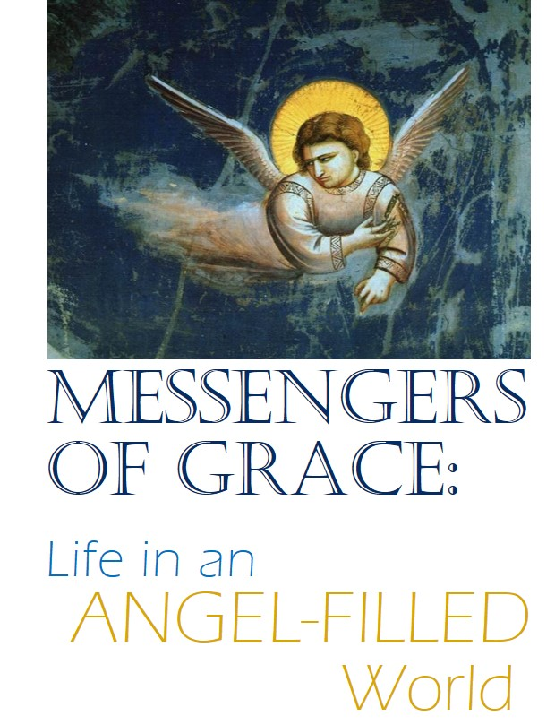

First Presbyterian Church
North East, PA
December 3, 2017, 4:00 P.M.

