THAT SPECIAL STAR

2016 Advent Program
First Presbyterian Church of North East, PA
December 4, 2016, 4:00 P.M.
Gregg D. Townsend, Pastor

*Indicates to stand if you are able

GATHERING MUSIC

FOLLOWING THE STAR: Lighting of the First Advent Candle

“Pause” Garrett, Scott & Tracey Connors

* CONGREGATIONAL HYMN Savior of the World

WELCOME/WORDS OF REFLECTION Donna Banks

READER #1 Sparrow Magill

* CONGREGATIONAL HYMN What Star Is This
FOLLOWING THE STAR: Lighting of the Second Advent Candle
“Listen” Sophie, Dianne & Don Tyler

“The Special Star”
Child – John McClure
Wise Person 1 – Mark Townsend
Wise Person 2 – Maddie Hartner

Reader #2: Tommy Hartner
Reader 3: Ashley Hartner

* CONGREGATIONAL HYMN Rise Up, Shepherd #50

A CHRISTMAS POEM “Christmas With Christ”
Makayla Albney & Ava Alcorn
SPECIAL MUSIC It Wasn’t Just Another Day Kids’ Choir

FOLLOWING THE STAR: Lighting of the Third Advent Candle

“Think” Jenn, Tom, John & Joel McClure

* CONGREGATIONAL HYMN Shine On Us

A CHILDREN’S CHRISTMAS STORY

FOLLOWING THE STAR: Lighting of the Fourth Advent Candle
“Pray” Terri, Bryan, Morgan & Drake Lash

SPECIAL MUSIC It Came Upon a Midnight Clear Sophie Tyler

WORDS OF REFLECTION “The Star” Brooks Townsend

SPECIAL MUSIC It’s Christmastime Kids’ Choir

* CONGREGATIONAL SONG Come Thou Long Expected Jesus

FOLLOWING THE STAR: Lighting of the Christ Candle
“Go” Jane Livingston, Gregg, Mark & Brooks Townsend

* BENEDICTION AND BLESSING FOR DINNER

* POSTLUDE

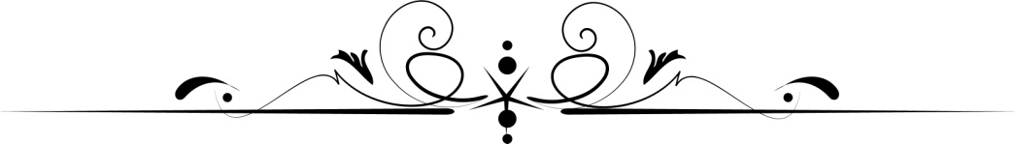

Please join us downstairs in Fellowship Hall for dinner, good conversation, and fellowship!

Schedule of Advent Events
At FPCNE

Sunday, December 11 at 8:30 & 11:00 am Advent Worship Services
Join us for worship on the third Sunday of Advent at 8:30 or 11:00 A.M. We will light the third Advent candle, and Pastor Townsend will offer a message on “A Star of Power.”

Sunday, December 18 at 11:00 am only Christmas Cantata and Worship Service
Share in this music-filled service on the fourth Sunday of Advent as we will light the fourth Advent candle and our Chancel Choir offers the cantata, “Come, Let Us Adore.” Pastor Townsend will continue our star theme with “A Star of Hope” message.

Saturday, December 24 at 7:30 pm Christmas Eve Candlelight Service
Join us for our Christmas Eve Candlelight Service. Pastor Townsend will share a special message on “A Star of Joy,” we will light the Christ candle, and our choirs will fill the air with music.

Sunday, December 25 at 11:00 am only Christmas Morning Worship Service
Pastor Townsend will lead us in a special Christmas Day service, including various readings and carols.

Sunday, January 1 at 11:00 am only New Year’s Day Worship Service
Begin the New Year by joining us for worship and celebrating communion, as Pastor Townsend resumes his series on Mark.

That Special Star
An Advent Program


First Presbyterian Church
North East, PA
December 4, 2016, 4:00 P.M.

